2026 DSES Kentucky State Assessment KSA Data
3rd Grade Reading
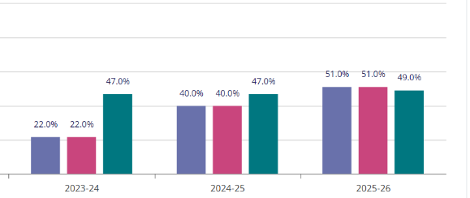
4th Grade Reading
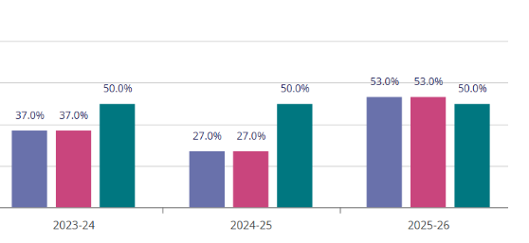
5th Grade Reading
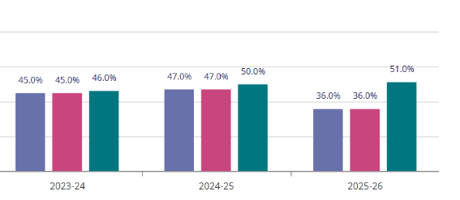
3rd Grade Math
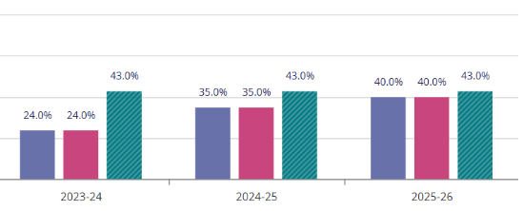
4th Grade Math
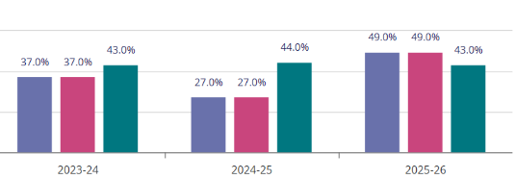
5th Grade Math
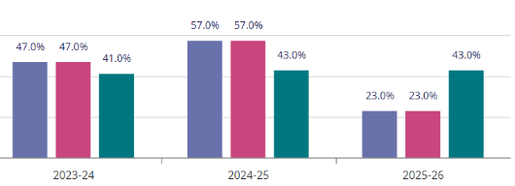

4th Grade Science
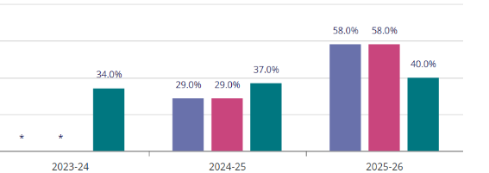
5th Grade Social Studies
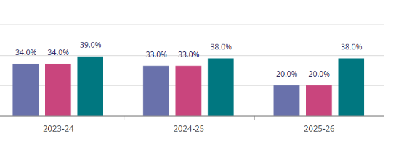
5th Grade Editing and Mechanics
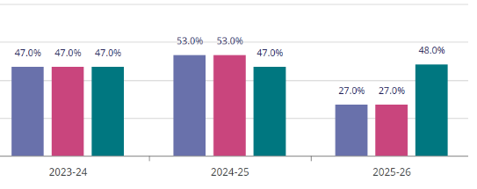

2026 DSES Kentucky State Assessment KSA Novice Reduction
3rd Grade Reading
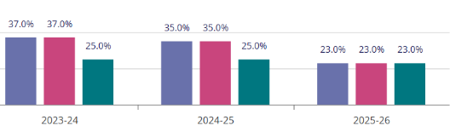
4th Grade Reading
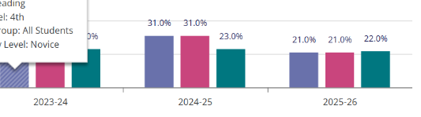
3rd Grade Math
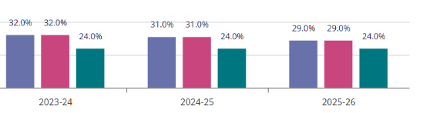
4th Grade Science


